

School of Applied Sciences  
Bachelor of Science in Computing

**COMP490 Final Year Project  
Weekly Status Report**Academic Year 2022/23

|  |  |
| --- | --- |
| Web-Based Fractal Visualization | |
|  |  |
| Project number: | Your project number |
| Student ID: | P1704690 |
| Student Name: | Timothy |
|  |  |
| Supervisor: | LIAM LEI |
| Assessor: | Your assessor |

Table of Contents

1 Preliminary Project Work Plan 2

2 First semester W4-W14 3

2.1 Week 4 3

# Preliminary Project Work Plan

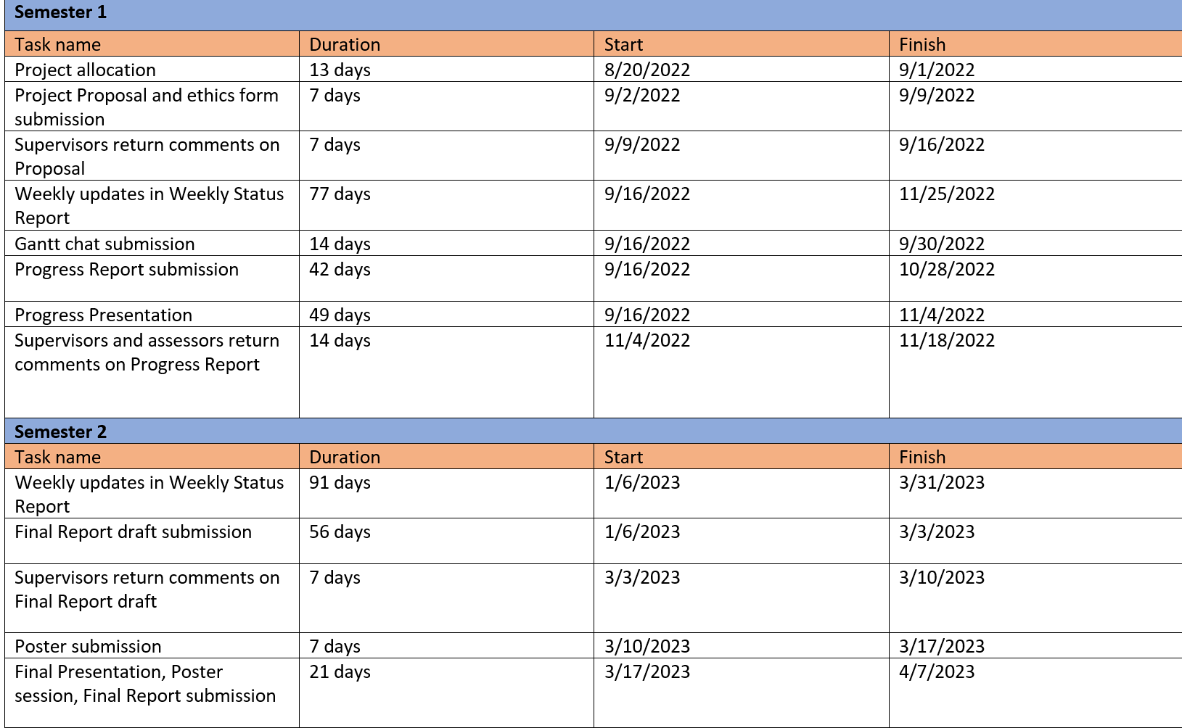

# First semester W4-W14

## Week 4

Report Date: 23/09/2022

### Tasks done this week

This week I’ve begun reviewing all the work from the previous year. I’m currently planning to add more fractal images to the site.

### Plan for next week

I plan on improve the base look on the site first for better viewing and use. It currently still at a base skeleton look.

## Gantt Chart

Modified Date: 23/09/2023

